|  |  |
| --- | --- |
| studywithme.ai | Koh Zheng Qiang Shawn |
| A0185892L |

I have always struggled with reading – words take much time to form, deciphering symbols and patterns makes me feel like I’m decoding the German Enigma messages with nothing more than a pen and paper. I am *Dyslexic*.

However, Dyslexia is *not me*. Fortunately (or unfortunately, if you ask my girlfriend), I am gifted with my father’s stubbornness – I refuse to be defeated by my learning difficulty. I read slowly? I give myself more time. It’s hard to read? I read it twice.

As you probably imagined, this is incredibly inefficient. But I stubbornly burn hours and hours a day reading, and re-reading, over and over again.

Until one fine day, I chanced upon two videos by Ali Abdaal which, as cliché as it may sound, *blew my mind*. He shared two evidence-based study strategies: [Active Recall](https://www.youtube.com/watch?v=ukLnPbIffxE&t=), and [Spaced Repetition](https://www.youtube.com/watch?v=Z-zNHHpXoMM).

I religiously followed his advice; I immediately bought Anki and sought to create magical flashcards that were supposed to help me study better. But there was a problem, *Anki sucked.* It’s user experience was terrible; I was spending more time figuring out how to use Anki than actually studying.

Frustrated, but still religiously devoted to the strategies, I sought out other solutions.

AnkiApp: I didn’t get past the login page, the app kept crashing out.

SuperMemo: No support for formatting mathematical equations

Quizlet: Too focused on learning languages

I had enough! This exercise in futility made me resort to using an Excel spreadsheet to study for the past semester.

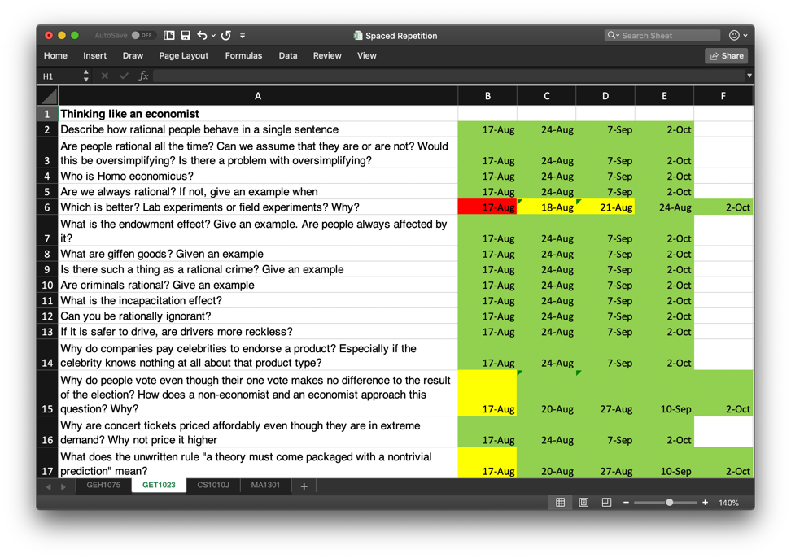

This simple spreadsheet was a paradigm shift in how I studied. I stopped re-reading the lecture notes. Instead, I read it once, made a list of questions, and constantly quizzed myself, recording how I performed for each question. If I found it challenging, I would test myself again the next day. If it was easy, I would test myself again in a longer duration in order to combat the forgetting curve.

But it was incredibly *tedious*. I had to manually calculate when was the next date to quiz myself, it was incredibly annoying to type my answer as I had to insert a new row and then delete it after. Inserting pictures ruined the spreadsheet’s formatting, formatting code was unfeasible: I couldn’t multi-color a single cell.

Enough! Nothing I tried has been satisfactory. If an adequate solution does not yet exist, I will create it myself!

studywithme.ai is the solution to help students learn better, faster. It is built on two leading [evidence-based study strategies](https://www.apa.org/science/about/psa/2016/06/learning-memory.aspx): Active Recall and Spaced Repetition.

Studying should be enjoyable, but it frequently results in an exercise in futility.

Let us help you make it simple.

To make studywithme.ai simple to use on any screen size, I am adopting a minimalistic theme and a mobile-first development approach.

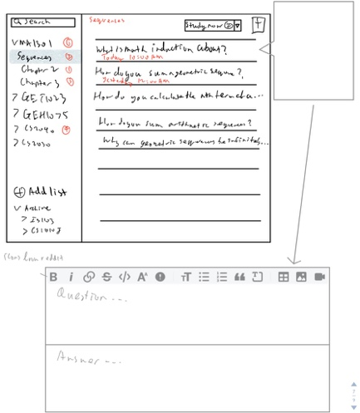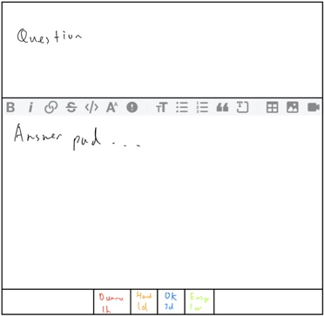I based the design on Apple’s Reminders and drew a sketch.

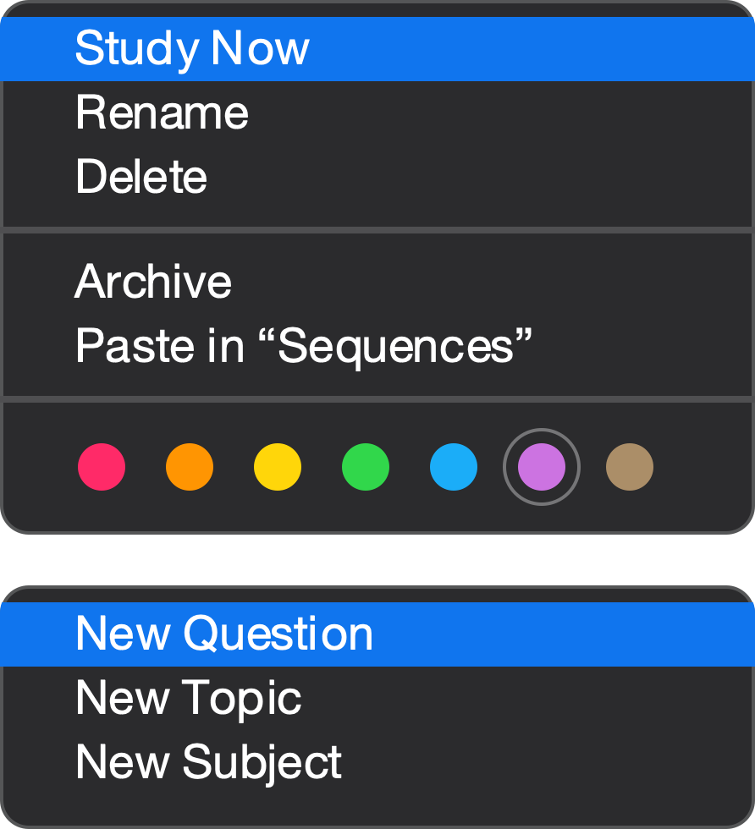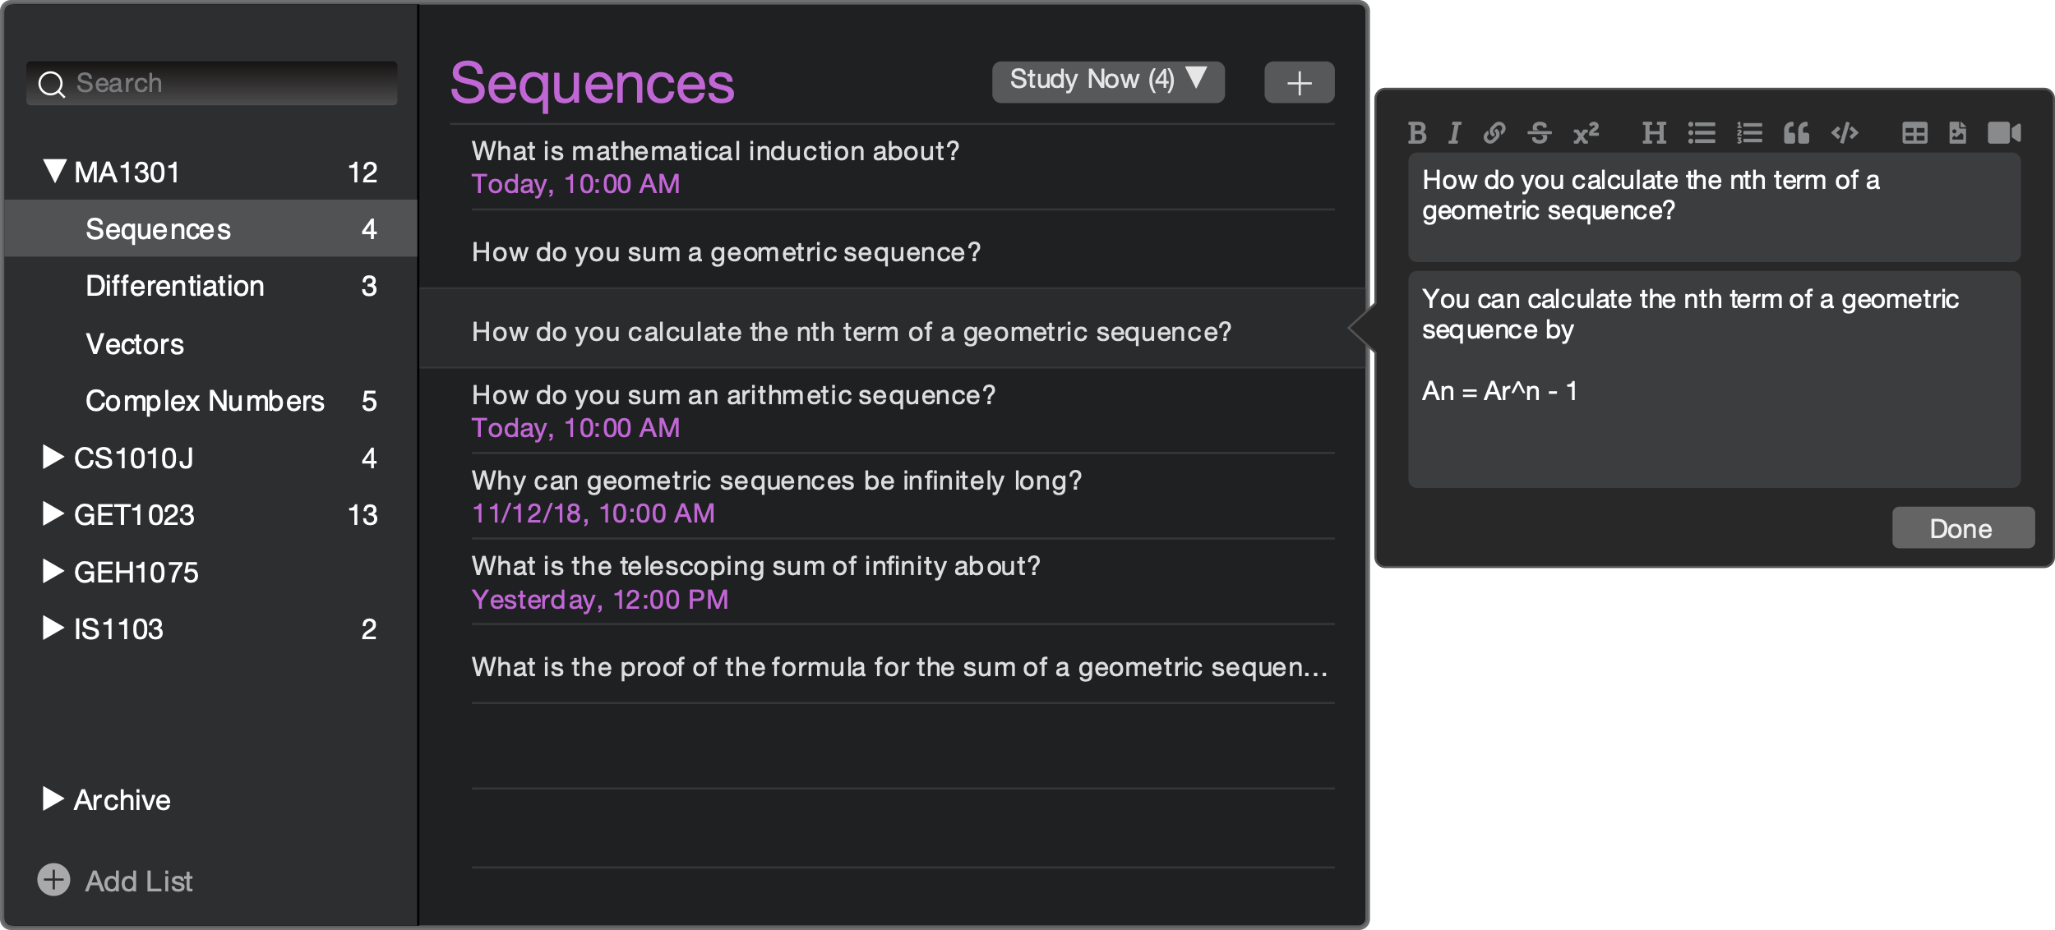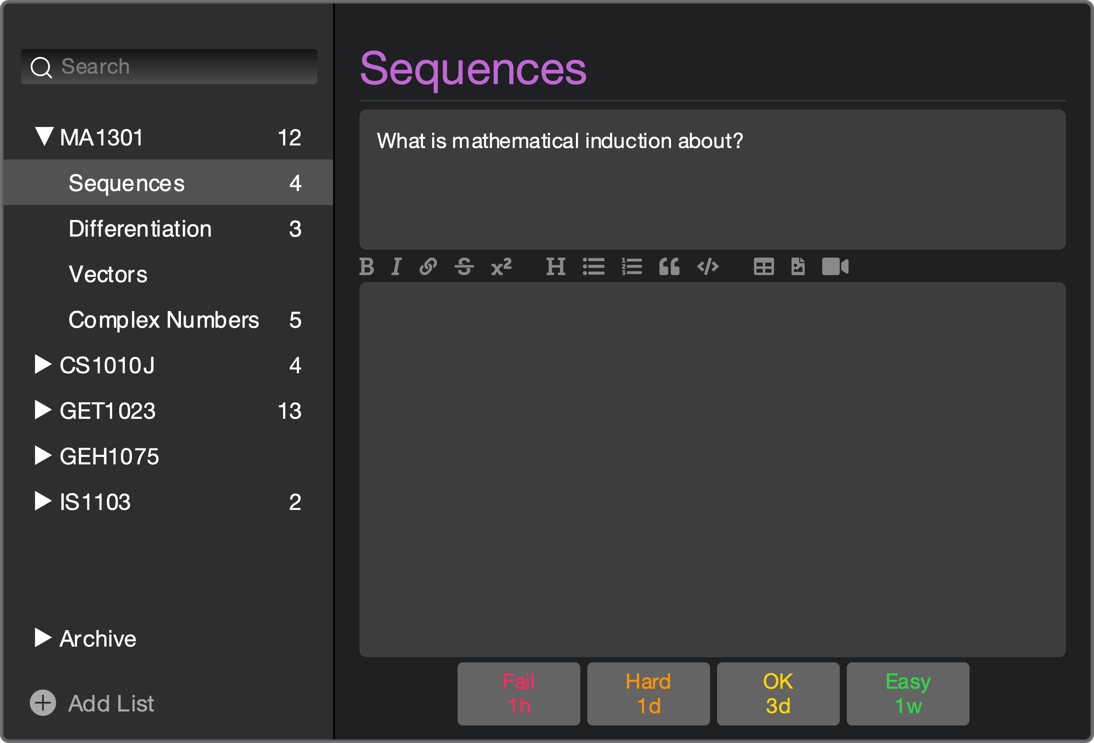Then, I mocked up a wireframe using Sketch App.

To focus on what really matters, I adopted [Li Hongyi’s methodology](https://youtu.be/PcmO-5VPaOE?t=724).

P1 – If not done we don’t launch

P2 – Important but can launch without if needed

P3 – Nice to have

|  |  |
| --- | --- |
| Allow users to create an account | P1 |
| Create, Read, Update & Delete Subject, Subject’s Topics, Topic’s Questions & Question’s Answer | P1 |
| Allow users to rearrange their Nav Bar | P1 |
| Allow users to rearrange Questions in a Topic | P1 |
| Begin quiz on a Subject / Topic | P1 |
| Provide an optional answer pad | P1 |
| Format text e.g. bold, italics, code, tables, (un)ordered lists | P1 |
| Rate how difficult a Question is, and test the user again in x hours based on his rating | P1 |
| Allow users to archive Subjects / Topics | P1 |
| Auto-backup Database | P2 |
| Add a Light Theme | P2 |
| Adjust the time before retesting a question by Topic / Subject | P2 |
| Inform user they have x questions that they need to revise daily via Push Notifications / Telegram / Email | P2 |
| Create a Landing Page | P2 |
| Mobile-ready | P2 |
| Tag topics to a color theme | P2 |
| Undo / Redo | P2 |
| Search for a Subject / Topic / Question | P2 |
| Keyboard shortcuts | P2 |
| Import decks from other apps like Anki / Excel | P3 |
| Support handwriting | P3 |
| Allow users to share their subjects with others on a Marketplace | P3 |
| Allow users to leave reviews on a Subject in a Marketplace | P3 |
| Help users to create good questions by detecting bad questions (NLP) and offering guides in a tooltip | P3 |
| Allow users to charge others for access to their subjects | P3 |
| Create a community forum to allow people to discuss decks | P3 |